**PORTABLE MIST FANS:**

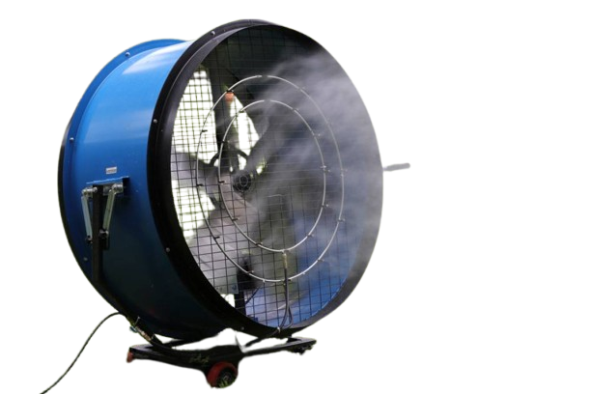

**Price: 20,000.00**

The Portable Mist Fan is a compact and versatile cooling solution, designed for on-the-go relief from the heat. With its lightweight design, rechargeable battery, and adjustable misting system, this fan is perfect for outdoor events, camping trips, beach days, and backyard gatherings. Its easy portability, quiet operation, and energy-efficient design make it an ideal choice for anyone seeking a convenient and effective way to stay cool anywhere, anytime.

**Key features of portable mist fans include:**

* **Compact and Lightweight**: Easy to move and store.
* **Misting Function**: Provides cooling through fine mist.
* **Adjustable Fan Speed**: Customizable airflow intensity.
* **Rechargeable or Battery-Powered**: For on-the-go use.
* **Energy Efficient**: Low power consumption.
* **Quiet Operation**: Minimal noise for convenience.